Vendor Information
Insight Optix
Mandi Ross, CEO
(615) 442-3450 (or 866.804.6876), info@insightoptix.com

315 Deaderick St., Suite 1550, Nashville, TN 37238
www.insightoptix.com
Company Description

Insight Optix is a legal technology company with the first and only SaaS-based solution in the market that addresses the longstanding problem of excessive and overzealous discovery. Its industry-leading technology and patented workflow, Evidence Optix®, empowers early discovery scoping, budget projections, proportionality analysis, and data source tracking throughout the litigation lifecycle.

Insight Optix is proud to be a WBENC-certified company that employs experts with decades of industry experience.

Vendor Offerings
Standard eDiscovery solutions focus on efficiencies post-collection, rather than the earlier stages of litigation where decisions significantly impact the cost and burden downstream. Evidence Optix changes this paradigm. As the only solution that begins in the identification stage of the EDRM, Evidence Optix provides a consistent and organized workflow for custodian and data evaluation that builds metrics to assist in proportionality analysis from the earliest stages of the matter.
Evidence Optix enables greater control, collaboration, and management of your entire litigation portfolio, while providing legal teams with the granular data necessary to articulate the burden and relevancy of discovery requests. This approach provides earlier insights for case strategy and settle or proceed decisions, and typically reduces discovery spend by 25-50%. Centralized collaboration with internal and external stakeholders facilitates documentation of decisioning and helps prevent inconsistencies, errors, data loss, and sanctions.

Sign off from organisation
Mandi Ross, CEO

Software Information

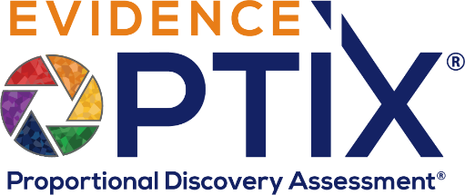
Evidence Optix® (EO) empowers early discovery scoping, budget projections, proportionality analysis, and data source tracking to reduce costs and risk throughout the litigation lifecycle. An attorney-driven SaaS solution, EO employs a simple, yet powerful workflow that commences in the gap between legal hold and collection – where early decisions significantly impact cost and burden downstream.
EO is user friendly, requires no software installation, employs no “black box” algorithms, and can be spun up in just a few days, so you can start experiencing the benefits of EO on your next matter.
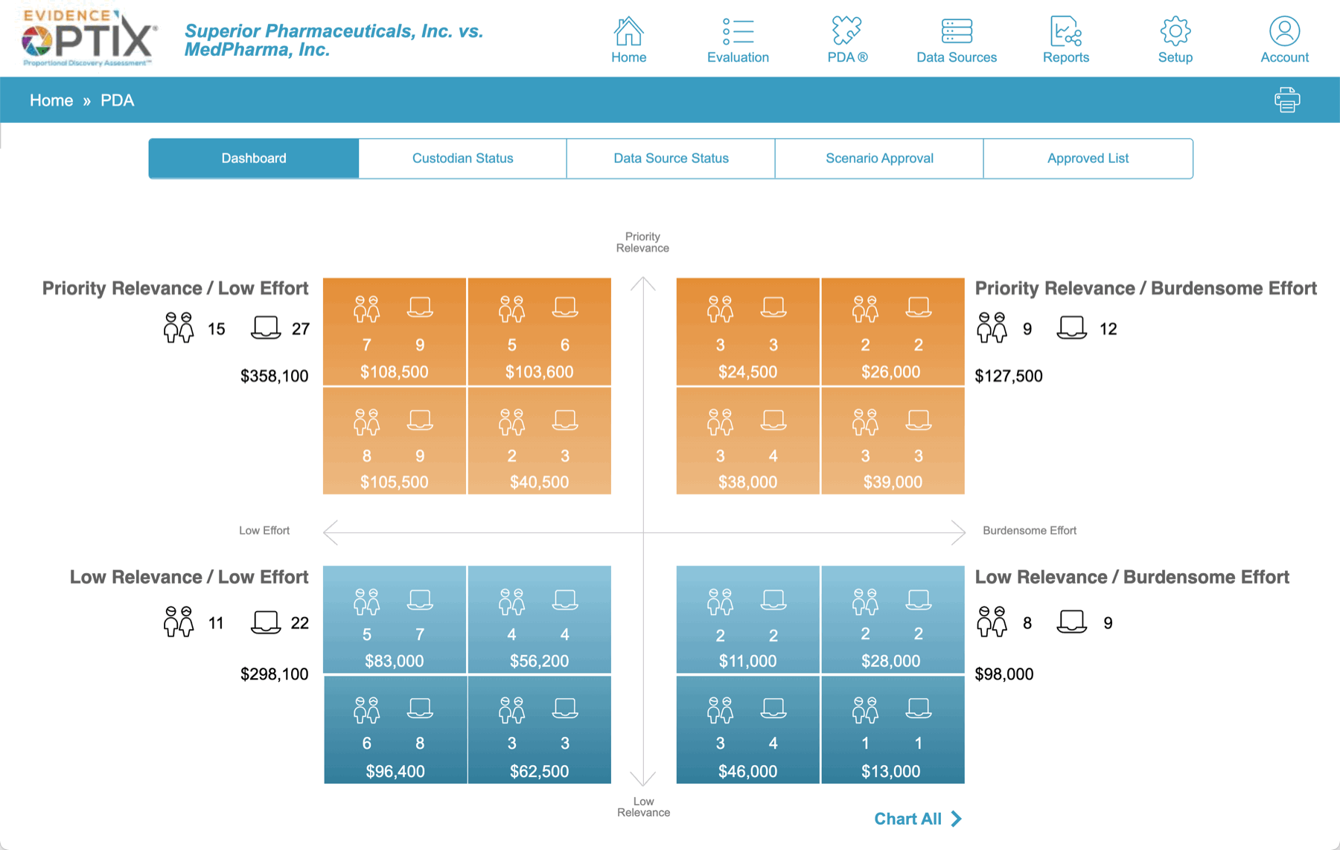
This game-changing framework:
- Guides legal teams through a systematic custodian and data assessment
- Ranks custodians based on their level of importance
- Scores data source burden and effort
- Calculates real-time cost projections
- Enables scenario generation for budgeting, negotiation, and proportionality arguments
- Provides a dynamic iterative process as the facts in dispute are refined

Learn more at https://insightoptix.com/evidence-optix-fe/.

